Turning Extension Infrastructure into Impact: Experimental Evidence from Punjab, Pakistan

Zartasha Zafar
PhD Candidate at the Department of Economics, National University of Sciences & Technology (NUST) Islamabad. (Email: zartasha.phde19s3h@student.nust.edu.pk)
Inayat Ullah
Assistant Professor, Department of Government & Public Policy, National University of Sciences & Technology (NUST) Islamabad. (email: inayat@s3h.nust.edu.pk)
Faisal Jamil
Professor, Department of Economics, National University of Sciences & Technology (NUST) Islamabad (Email: faisal.jamil@s3h.nust.edu.pk)

Abstract
Rice is a vital crop for household food security and the national economy in Pakistan, contributing 0.7% to GDP, 3% to agricultural value added, and ranking as the country’s second-largest export after cotton. However, rice yields among small-scale farmers remain suboptimal, partly due to limited access to timely and locally relevant agronomic knowledge. This study leverages a natural experiment in two major rice-producing districts of Punjab, Pakistan, to estimate the causal effect of targeted agricultural training on rice productivity and farm incomes. Farmers with small to medium landholdings and at least two years of farming experience were selected for the experiment conducted in collaboration with the provincial extension department and community leaders. Treated villages received structured, phase-based agronomic training before and during the Kharif season, while selected control villages did not receive such support. Using baseline and endline surveys, along with a difference-in-differences estimation strategy that controls for village fixed effects, we find that the intervention increased average rice yields by 4.64 maunds per acre (approximately 185 kilograms), thus significantly raising per-acre revenues. Importantly, our baseline analysis reveals no significant yield differences between areas with and without extension staff, underscoring that the mere presence of extension infrastructure does not translate into productivity gains unless accompanied by timely, zone-centered knowledge transfer to farmers. These results highlight that while public extension systems are a necessary delivery channel, their impact remains limited without strengthened capacity, targeted training, and active engagement with farmers. The findings provide actionable insights for policymakers seeking cost-effective ways to reduce yield gaps and enhance rural welfare by leveraging underutilized extension infrastructure as an effective tool for knowledge dissemination and agricultural growth.

Key Words: Agricultural Extension Services, Rice Yield, Information Dissemination, Natural Experiment
JEL Classification: O13,Q12, Q16, C93
Turning Extension Infrastructure into Impact: Experimental Evidence from Punjab, Pakistan

Abstract
Rice is a vital crop for household food security and the national economy in Pakistan, contributing 0.7% to GDP, 3% to agricultural value added, and ranking as the country’s second-largest export after cotton. However, rice yields among small-scale farmers remain suboptimal, partly due to limited access to timely and locally relevant agronomic knowledge. This study leverages a natural experiment in two major rice-producing districts of Punjab, Pakistan, to estimate the causal effect of targeted agricultural training on rice productivity and farm incomes. Farmers with small to medium landholdings and at least two years of farming experience were selected for the experiment conducted in collaboration with the provincial extension department and community leaders. Treated villages received structured, phase-based agronomic training before and during the Kharif season, while selected control villages did not receive such support. Using baseline and endline surveys, along with a difference-in-differences estimation strategy that controls for village fixed effects, we find that the intervention increased average rice yields by 4.64 maunds per acre (approximately 185 kilograms), thus significantly raising per-acre crop revenues. Importantly, our baseline analysis reveals no significant yield differences between areas with and without extension staff, underscoring that the mere presence of extension infrastructure does not translate into productivity gains unless accompanied by timely, zone-centered knowledge transfer to farmers. These results highlight that while public extension systems are a necessary delivery channel, their impact remains limited without strengthened capacity, targeted training, and active engagement with farmers. The findings provide actionable insights for policymakers seeking cost-effective ways to reduce yield gaps and enhance rural welfare by leveraging underutilized extension infrastructure as an effective tool for knowledge dissemination and agricultural growth.

Key Words: Agricultural Extension Services, Rice Yield, Information Dissemination, Natural Experiment
JEL Classification: O13,Q12, Q16, C93
- Introduction
Information frictions persist as a significant barrier to agricultural productivity growth across developing countries. Public extension systems are designed to bridge the yield gaps by delivering timely and relevant agronomic information. Even where improved seed varieties, modern inputs, and cultivation techniques are physically available, adoption often lags due to gaps in farmers’ awareness and technical know-how. These knowledge gaps are especially pronounced in contexts where public extension services are under-resourced, coverage is patchy, and advisory visits are infrequent (Anderson & Feder, 2004; Lobell et al., 2009; Ferroni & Zhou, 2012; Driessche, 2024). In such settings, information itself becomes a critical but missing input in the agricultural production function. Likewise, in Pakistan, the performance of the extension system has been constrained by staffing shortfalls, low visit frequencies, limited monitoring, and credibility challenges. Field assistants (FAs), the frontline of the extension network, are tasked with advising farmers on seed selection, cultivation practices, input use, and pest management. Nevertheless, smallholder farmers often receive inconsistent guidance and instead rely on informal networks, pesticide dealers, or private agents, whose advice may be fragmented or misaligned with productivity goals (Adio et al., 2016).
This paper examines whether enhancing the delivery of context-specific agricultural information through existing public extension channels can significantly improve farm-level productivity. We evaluate a field-based natural experiment implemented in partnership with the Punjab Department of Agriculture across two central rice-growing districts in Punjab. Villages in the treatment group received two rounds of in-season, locally tailored agronomic training delivered by FAs prior to the Kharif season. The curriculum focused on varietal selection, seedbed preparation, irrigation scheduling, fertilizer management, and pest control. We selected comparable control villages that did not receive any additional extension support during the same period.
To estimate the causal impact of updated agronomic information on rice productivity, we collected detailed baseline and endline survey data from 469 rice farmers and employed a difference-in-differences research design. We find that farmers in treated villages experienced significant gains in rice yields and crop revenues relative to their control counterparts, without any corresponding increase in input use or cultivated area. This suggests that timely, locally relevant information provided on time may enable farmers to optimize input use and increase productivity at a low marginal cost.
Our study contributes to several strands of literature. First, it adds to the growing evidence on how information frictions hinder technology adoption and limit agricultural productivity (Foster & Rosenzweig, 1995; Munshi, 2004; Bandiera & Rasul, 2006; Conley & Udry, 2010; Takahashi et al., 2019). Several papers emphasize the crucial role of targeted, site-specific agronomic information, whether delivered through traditional extension agents (Ayalew et al., 2022; Kondylis et al., 2017) or digitally via mobile phones and peer-to-peer platforms (Baul et al., 2024; Cole et al., 2025; Lasdun et al., 2025). Tailoring recommendations to local conditions and gender-specific needs may enhance both adoption rates and the cost-effectiveness of interventions (Ayalew et al., 2022; Baul et al., 2024).
Second, while recent research has explored alternative extension models and peer learning in various crops and contexts, rigorous causal estimates of updated knowledge provision in smallholder rice systems remain scarce. For instance, some studies suggest the combination of digital and group-based extension methods can improve knowledge diffusion, with interactive formats such as SMS chat groups and video-based instruction facilitating farmer-to-farmer learning and uptake of sustainable practices (Lasdun et al., 2025; Baul et al., 2024). However, these approaches complement rather than replace traditional peer networks, as mobile-based services sometimes reduce but do not eliminate informal advice exchanges (Fernando, 2021). In terms of constraints to adoption, multiple studies underscore that information alone is insufficient. Bundled interventions that address financial, informational, and infrastructural barriers simultaneously result in significantly greater productivity and profitability gains (Deutschmann et al., 2025; Gebresilasse, 2023)—for example, combining credit access with extension services substantially raised maize yields and profits in Kenya (Deutschmann et al., 2025). Physical infrastructure improvements, particularly rural road development, serve as critical complements to extension, expanding market access and facilitating the adoption of farm inputs, yielding synergistic effects when paired with advisory services (Gebresilasse, 2023). Furthermore, the existing literature also examines heterogeneity in technology adoption dynamics related to farmers’ cognitive abilities and social learning traits. Early adopters tend to be those with high cognitive skills but lower responsiveness to advice. In contrast, slower adopters often rely more on peer influence, emphasizing the need for differentiated extension strategies (Barham et al., 2018). Institutional and economic incentives also influence the quality and reach of service delivery. For instance, regulatory interventions such as price caps may increase affordability but reduce the incentive for extension agents to serve remote farmers, potentially hindering the widespread adoption of these practices (Blum, 2020). Similarly, the use of advanced technologies, including remote sensing and satellite data, enhances the precision of adoption and yield measurements in impact evaluations, helping to overcome traditional data limitations and improve program targeting (Cole et al., 2025). However, much of the literature suggests that effective agricultural extension requires multifaceted, context-aware approaches that combine tailored agronomic advice, leverage digital tools and social learning, address complementary constraints, and integrate institutional considerations to maximize smallholder productivity and technology adoption at scale.
By leveraging natural variation in extension capacity, we provide new causal evidence on how targeted information interventions can close persistent yield gaps in rice, a crop of critical importance for food security and export earnings in Pakistan. Third, our findings contribute to policy debates on designing low-cost, scalable extension reforms that leverage existing institutional structures to deliver impactful services.
The remainder of the paper is organized as follows. Section 2 describes the institutional background and experimental design of agricultural extension services in Punjab, explaining the experimental approach. Section 3 details the study setting, data collection, and empirical strategy, with an emphasis on the approach to the difference-in-differences analysis. Section 4 presents the results, and Section 5 concludes the study, highlighting policy implications and avenues for future research.
- Project Description and Experimental Design
This study was conducted among smallholder rice farmers in central Punjab, focusing on the districts of Gujranwala (32°9′24″N, 74°11′24″E) and Sheikhupura (31°42′59.98″N, 73°59′6.08″E). In the 2021–22 season, Gujranwala recorded a total agricultural output of 564,170 tonnes cultivated over 260,210 hectares, while Sheikhupura produced 483,040 tonnes on 243,210 hectares (Government of Pakistan, 2022). Specifically, basmati rice accounted for a significant share: Sheikhupura produced 376,720 tonnes with an average yield of 19.5 maunds per acre, whereas Gujranwala produced 119,560 tonnes with an average yield of 17.38 maunds per acre (CRS, 2022).
  - Agricultural Extension Structure in the Study Region
The primary mandate of the Agricultural Extension Department in Punjab is to deliver updated agronomic knowledge and promote improved agricultural technologies to enhance per-acre productivity. To this end, the department organizes Farmer Training Programs (FTPs) at the village level. These sessions inform farmers about disease-free, cleaned, and graded seeds, as well as suggest high-yielding varieties, optimal seed rates, and improved cultivation methods.
The extension program for rice is delivered in two structured phases:
Phase I: Farmers receive training on key agronomic practices, including seed selection, land preparation, sowing methods, irrigation scheduling, and overall cultivation techniques. This phase is implemented over six weeks to cover all villages in the targeted districts.
Phase II: Farmers are trained in plant protection practices, with a focus on the calibrated use of pesticides, fungicides, and herbicides. Proper timing and dosage are emphasized due to their critical role in maximizing yields. Phase II is also completed within a six-week window.
The department employs two primary methods for delivering information: (1) group contact methods, such as large farmer gatherings, field days, and FTPs, and (2) individual contact methods for tailored advice. Information is further disseminated through pamphlets, demonstration plots, and SMS alerts. This study employed the FTP approach, which brings farmers together at a central village location for standardized training. The intervention specifically targeted smallholders with landholdings ranging from 5 to 30 acres.
  - Experimental Design and Implementation
Prior to implementation, we conducted extensive consultations with the Punjab Agricultural Extension Department to coordinate logistics, align on program objectives, and ensure institutional buy-in. Because extension agents remain the primary source of agronomic guidance for smallholders in the region, this collaboration was crucial for ensuring credibility and local relevance. A structured household questionnaire was designed in collaboration with senior research staff to capture comprehensive farm-level and socioeconomic data. Data collection occurred in two rounds: a baseline survey conducted in April 2023, prior to paddy cultivation, and an endline survey immediately following the rice harvest. The baseline survey recorded socioeconomic characteristics, ownership of agricultural machinery, access to credit, varietal use, and prior-season rice yields. All baseline interviews were conducted in person, with respondents informed that they would be re-contacted after harvest to collect follow-up information on yields and revenues. Figure 1 describes the timeline and implementation of the intervention. The rice cultivation season typically runs from May to November, lasting around 120 days. During the 2023-24 rice cropping season, agricultural extension agents provided training on best practices for rice cultivation to farmers in these areas. The training included all pertinent topics and was strategically provided to a treatment group of 237 farmers from tehsil Nowshera (District Gujranwala) and tehsil Sheikhupura (District Sheikhupura) as part of the intervention. Table 1 presents the summary statistics on key variables in this study.
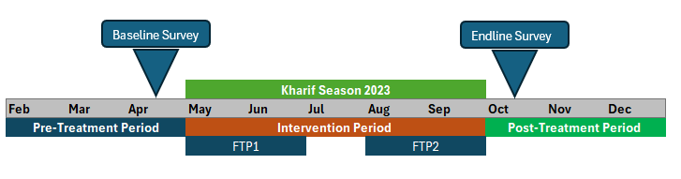
Fig. 1. Timeline and Implementation of the Intervention:
Note: During the FTP-I phase, information was provided on seed selection, sowing methods, irrigation practices, land preparation, and cultivation techniques. In the FTP-II phase, the focus was shifted to guidance on pesticide, fungicide, and weedicide application.
The intervention was delivered in two phases, aligning with the standard FTP schedule:
FTP-I (May–June):
- Trained extension agents conducted structured training sessions on seed selection, land preparation, improved sowing methods, irrigation practices, and overall cultivation techniques. All sessions were delivered under the direct supervision of researchers to ensure fidelity to the intervention protocol.
- Following the sessions, farmers were encouraged to maintain contact with extension agents. Contact numbers were provided, and farmers were advised to send crop photographs if problems arose and to visit extension offices for further support. Interactive Q&A segments during sessions enabled farmers to raise context-specific queries and receive tailored advice.
FTP-II (August–September):
- Extension staff independently administered advanced training on integrated pest management, including recommended timing and dosage of fungicides, herbicides, and pesticides.
- Intervention fidelity and information retention were verified through the endline survey and follow-up interactions with participating farmers.
Due to logistical constraints, the second survey round was conducted over the phone. To mitigate non-response bias, we employed a peer-referral strategy: respondents who could be reached in each village were asked to help locate initially unreachable participants and facilitate contact for follow-up interviews. In total, information sessions were organized in 22 villages, with each session lasting approximately two hours.
  - Selection of Treatment and Control Villages
The identification strategy for this study exploits naturally occurring variation in the availability of agricultural extension services across tehsils in central Punjab. In consultation with the Punjab Agricultural Extension Department, we selected two tehsils in each of the districts of Gujranwala and Sheikhupura based on the pre-existing presence or absence of extension service coverage for rice cultivation. In each district, one tehsil with established extension service infrastructure was designated as the treatment area, while a comparable tehsil lacking such coverage served as the control. Specifically, in the Gujranwala district, Nowshera Virkan (NWV) tehsil received the extension-led intervention, whereas Kamoke (KMK) tehsil served as the control. In the Sheikhupura district, the Sheikhupura (SKP) tehsil was assigned for treatment, and the Muridkey (MDK) tehsil served as the control. This pre-existing institutional arrangement created plausibly exogenous variation in farmers’ access to updated agronomic information, allowing us to implement a difference-in-differences design to estimate causal impacts. Within each treatment tehsil, 24 villages were randomly selected from official lists provided by the Extension Department. Similarly, 12 villages were randomly chosen across the two control tehsils to provide a comparable baseline and follow-up group. Within each selected village, we compiled lists of eligible smallholder rice farmers in collaboration with local extension staff and community leaders. Farmers were then randomly sampled to participate in the baseline and endline surveys.
Participation in the training sessions varied by village, depending on local attendance and farmer availability; however, all surveyed farmers in the treatment villages were either directly or indirectly exposed to the intervention through local extension activities. Data was collected from all sampled farmers at baseline and endline. The initial baseline sample targeted 500 farmers, with a final panel of 469 farmers successfully surveyed in both rounds due to minor attrition. Figure 2 illustrates the geographic distribution of the sampled tehsils and villages. Brown dots indicate villages in treatment areas, while control villages are shown in white. Detailed demographic and farm-level information was collected for each farmer, including landholding size, years of experience in rice farming, household size, and the highest educational attainment within the household.
Districts
Tehsils
Villages distribution

Figure 2: Sampling Design and Allocation of Treatment and Control Groups
- Theoretical Framework
We interpret our findings through the lens of three theories in the literature on agricultural decision-making under uncertainty and the role of technology adoption: learning through noticing by Hanna, Mullainathan, and Schwartzstein (2014), learning new technology by Conley and Udry (2010) and receptiveness to advice by Barham, Chavas, Fitz and Schechter (2018). Smallholder farmers often operate with incomplete information about the productivity returns to new agronomic practices and input combinations. As Conley and Udry (2010) demonstrate in the context of pineapple cultivation in Ghana, farmers rely on credible information sources, whether social networks or formal extension services, to update beliefs about expected returns, thereby reducing uncertainty and enabling more efficient input choices. Complementing this perspective, Hanna, Mullainathan, and Schwartzstein (2014) highlight that even when information is available, behavioral frictions such as limited attention or cognitive overload may prevent farmers from recognizing and responding to critical agronomic details.
Structured interventions that highlight best practices can help overcome this constraint, redirecting farmers’ focus to aspects of production that directly affect yield. Taken together, these theoretical insights suggest that locally tailored and timely delivered extension services function both as a credible source of information that reduces uncertainty (Conley & Udry, 2010) and as a mechanism that heightens awareness of optimal practices (Hanna et al., 2014). By doing so, the intervention relaxes knowledge and attention constraints that otherwise lead to suboptimal input use. The observed gains in rice yield and crop revenue in this study, without significant changes in input quantities, are consistent with this framework. Farmers would adjust their practices closer to the agronomic optimum once credible, actionable information is provided at the right time.
We consider a setting in which farmers choose an input level, such as the appropriate quantity of fertilizer or the correct plant spacing, to maximize crop output. Let z* represent the agronomic optimum for this input under local conditions. However, farmers do not observe z* directly. Instead, they hold a subjective belief ẑ_{it} which evolves as they receive new information. The realized input used by the farmer in period t is denoted by a_{it}​, and the yield is increasing in how close a_{it}​ is to the actual optimal level.
In the absence of reliable information, farmers may rely on cropping patterns, local norms, or noisy signals from their own or others’ past experiences. As a result, many operate at levels of input that are significantly removed from the agronomic optimum, contributing to yield gaps. The provision of credible, targeted information through extension services can alter these beliefs and encourage farmers to make more informed decisions about their inputs. Our model assumes that extension agents provide a noisy but informative signal about z*. Farmers then update their beliefs by combining their prior knowledge with the new signal. We denote a farmer's receptiveness to advice as β​, which reflects the weight they place on the signal relative to their own prior belief. Formally, the updated belief is a convex combination:
$${ẑ}_{it}=\left(1-β_{i}\right)P_{i,t-1}+β_{i}c_{it} (1)$$
Where ẑ_{it} is the updated belief about the optimal input in period t, P_{i,t-1} is the farmer’s belief prior to receiving extension advice, c_{it} is the signal received from the extension agent, and β_{i} ∈ [0,1] is the farmer’s receptiveness to extension training. The parameter β_{i} may vary across farmers based on their trust in public institutions, prior experiences with extension services, or individual openness to changing their behavior. Once the belief ẑ_{it} is formed, the farmer chooses an input level a_{it}​ ​. In the simplest case, we assume the farmer selects a_{it} = ẑit, implementing the practice they consider optimal. As β_{i} increases and c_{i} becomes more precise, a_{it} moves closer to z*, and yield increases correspondingly. Significantly, the productivity gain from the intervention depends not only on the quality of the signal but also on the farmer’s receptiveness. Two farmers receiving the same information may respond differently, depending on their level of trust in that advice.
In our setting, the decision to act on extension advice is modeled as a discrete behavioral choice. Upon receiving a signal from the extension agent about improved input use, such as optimal spacing, transplanting methods, or fertilizer application, a farmer decides whether to adjust their existing practices. This decision depends on whether the perceived benefit of changing behavior exceeds an individual threshold, which captures perceived costs, uncertainty, or behavioral inertia. These costs may include the time and effort required to modify familiar routines, skepticism about the advice, or constraints such as labor availability. Farmers who view the signal as credible and assume the expected gains are `sufficiently large are more likely to adopt the recommended changes. In this way, adoption is conceptualized not as a shift to an entirely new technology, but as a targeted adjustment within the current production system driven by formal, advisor-based learning. This formulation enables us to interpret observed changes in behavior among treated farmers as the adoption of improved practices in response to extension-delivered information.

The above theoretical framework motivates three empirical predictions. First, treated farmers who received extension advice are expected to revise their view about input use and adjust their behavior accordingly. Second, the magnitude of this adjustment will vary with each farmer’s receptiveness to advice, denoted β_{i}​, which we proxy using observable characteristics such as prior farming experience, exposure to extension services, or reported trust in public information sources. Third, yield improvements should reflect both the precision of the advice provided and the extent to which farmers respond by updating their practices. By embedding our intervention within this learning-from-advice framework, we interpret observed changes in input use and productivity as evidence of belief updating driven by formal extension. Figure 3 illustrates expected relationships in the absence and presence of targeted training and information. The mere presence of agricultural extension staff in a tehsil does not lead to yield improvements unless they conduct targeted training for small-scale farmers. Our baseline survey revealed no statistically significant differences in rice yields between tehsils with and without extension services. This highlights that while extension services are a necessary delivery channel, their current form is insufficient. To enhance crop productivity, it is crucial to enhance the capacity of extension staff and ensure the provision of timely, localized, and up-to-date agricultural information. In this context, the presence of government infrastructure presents an opportunity for scalable interventions, but without targeted content and engagement, its impact remains limited.
Presence of extension staff
Targeted Training (T)
Technology Adoption
Lack of Targeted Training (C)
Low Yield
Absence of Extension Staff
Lack of Targeted Training (C)

High Yield

Fig 3. Pathways Linking Extension Services and Targeted Training to Rice Yield: This diagram illustrates the causal mechanism tested in this study. In the absence of extension staff, farmers lack access to targeted agronomic training, contributing to persistently low yields (control group). Where extension staff are present and targeted training is delivered, farmers receive updated, locally relevant information that enables improvements (treatment group). The diagram illustrates the core hypothesis that credible, timely information enhances productivity by alleviating information and attention constraints.
- Data and Methods
The data for this study were collected in collaboration with the public extension department, with the assistance of an extension agent who facilitated both in data collection and information dissemination to participants. The panel survey targeted small-scale farmers with land holdings ranging from 5 to 30 acres in the Gujranwala and Sheikhupura districts of Punjab, Pakistan. Farmers were selected based on criteria that included landholdings and a minimum of two years of rice farming experience. Rice and wheat are the primary crops cultivated in these regions. Table 1 shows the summary statistics of the variables used in this study.
Table 1. Summary Statistics (Pooled Dataset of Baseline and Endline Survey)
Variable | Obs | Mean | Std. Dev. | Min | Max
Average Yield (Maunds) | 938 | 40.65 | 9.13 | 11 | 65
Average Revenue (PKR) | 938 | 149,855 | 37,550 | 48,400 | 260,000
Expenditures per Acre (PKR)\ | 938 | 78,918 | 55,722 | 9600 | 790,076
Land Size (Acres) | 938 | 16.79 | 9.55 | 5 | 30
Total Farming Experience | 938 | 22.19 | 13.93 | 3 | 50
Number of Agricultural Machinery | 938 | 3.37 | 2.14 | 0 | 8
Farmer Family Size (Members) | 938 | 9.83 | 4.50 | 2 | 35
Age | 938 | 40.83 | 13.71 | 20 | 67
Farmers’ Education (Years) | 938 | 4.60 | 1.83 | 2 | 8
Marital Status of Farmer (Yes=1) | 938 | 0.83 | 0.37 | 1 | 2
Highest Level Education in the HH | 938 | 5.37 | 1.39 | 1 | 8
Information application | 474 | 0.63 | 0.48 | 1 | 2
Satisfaction with Extension Dep (Yes=1) | 474 | 0.43 | 0.50 | 1 | 2
No of visit | 190 | 1.32 | 0.47 | 1 | 2
Notes: The data on these variables were collected in two rounds: (1) Baseline survey and (2) Endline Survey from rice farmers in the study area. Table 1 presents an overall summary of the variables used in the data. Variable Average Yield is measured in Maunds per acre by the farmer. Variable Average Revenue is measured in PKR per acre. Since the information application and satisfaction with the extension department were only observed in the end-of-hour survey, the observations shown are low. Many farmers had not visited the extension services office; therefore, the number of observations for the visit variable is 190.

  - Identification Strategy
This study leverages naturally occurring institutional variation in the availability of agricultural extension services across tehsils in Punjab, Pakistan, to identify the causal impact of providing updated, targeted agronomic information on rice yields. Specifically, the presence of extension staff in certain tehsils, determined by pre-existing government infrastructure and staffing patterns, creates plausibly exogenous variation in farmers’ baseline access to formal advisory services. This institutional feature forms the basis for a natural experiment, as the mere presence of extension staff does not guarantee improved productivity in the absence of relevant and timely training. We provide evidence of no difference between the to-be-treated villages, where extension services were available, and the to-be-controlled villages, where extension staff were not present. Table 2 reports mean comparisons across key variables to assess baseline balance. The results indicate that randomly drawn samples of farmers from treatment and comparison groups before the interventions were similar in terms of average rice yield, expenditure per acre, and average land size.

Table 2: Baseline Test: Mean Comparison Test Between the To-be-treated and Control Group
 | Treatment | Control | Difference | S.E.
Average Yield (Munds) | 45.734 | 44.556 | -1.178 | 0.640
Average Revenue (PKR) | 155,825 | 144,241 | -11,584*** | 3,070
Expenditure per Acre (PKR) | 77,639 | 80,224 | 2,584 | 5,153
Farmer Family Size (Members) | 10.241 | 9.405 | -0.835* | 0.415
Age | 40.536 | 41.134 | 0.598 | 0.896
Farmers’ Education (Years) | 4.460 | 4.741 | 0.281 | 0.168
Total Farming Experience | 21.038 | 23.375 | 2.337 | 1.284
Land Size (Acres) | 16.460 | 17.121 | 0.661 | 0.882
Marital Status of Farmer (Yes=1) | 1.152 | 1.185 | 0.033 | 0.035
Highest Level Education in the HH | 5.439 | 5.302 | -0.137 | 0.129
Number of Agricultural Machinery | 2.127 | 2.203 | 0.076 | 0.218
Observations | 237 | 232
Notes: The baseline test is conducted using the survey data collected prior to the treatment in April. Average Yield and revenue are measured on a per-acre basis. Farming experience refers to rice farming experience, with a minimum of two years for the representative farmers in this study. The highest level of education in the HH measures the highest education level in the farmer’s family. Agricultural machinery is measured as the total number of pieces of machinery observed among farmers during the survey. Expenditures measured in PKR per rice season include the costs incurred on fertilizers, pesticides, weedicides, water, and the purchase of seed varieties. Groups were selected for control and treatment based on whether extension staff were present or not. Statistical significance at the 1%, 5%, and 10% levels is indicated by ***, **, and, respectively.
To evaluate the effect of delivering targeted agronomic information through existing extension channels, we employ a Difference-in-Differences (DiD) approach that compares yield outcomes between treatment and control villages before and after the intervention. The treatment group consists of farmers in villages located within tehsils with established extension staff who received two rounds of structured training sessions prior to and during the rice-growing season. The control group comprises comparable villages in tehsils lacking such extension service coverage and therefore did not receive additional information or training during the study period.
The baseline survey confirmed that, prior to the intervention, there were no statistically significant differences in average rice yields between treatment and control tehsils. This supports the parallel trends assumption required for DiD estimation, conditional on observable characteristics and village-specific fixed effects. Village selection within each tehsil further strengthens the design. Within treatment tehsils, 22 villages were randomly selected from official lists provided by the Extension Department, while 11 villages were randomly selected from control tehsils in the same districts. Farmers were then randomly sampled within each selected village and surveyed both before (baseline) and after (endline) the intervention.
3.2. Empirical Specification
Our primary empirical specification estimates the following Difference-in-Differences model:
$$Y_{ivt}=α+β_{1}{Treatment}_{i}×{Post}_{t}+β_{2}{Treatment}_{i}{+β}_{3}{Post}_{t}+β_{4}X_{ivt}+γ_{v}{+ϵ}_{ivt}$$

Where:
$Y_{ivt}$is the rice yield per acre (measured in maunds) for farmer i in village v at time t (baseline or endline).
${Treatment}_{i}$is an indicator equal to 1 if the farmer resides in a village within a treatment tehsil and participated in the targeted training, and zero otherwise.
${Post}_{t}$is an indicator equal to 1 for the post-intervention period (endline) and 0 for baseline.
The interaction term ${Treatment}_{i}×{Post}_{t}$​ captures the diff-in-diff estimate of the causal effect of receiving updated agronomic information.
$X_{ivt}$is a vector of time-varying farmer and farm-level controls, including landholding size (acres), total farming experience (years), number of agricultural machines owned, expenditure per acre (PKR), family size, farmer’s education, household’s highest education level, and farmer’s age.
$γ_{v}$denotes village fixed effects to account for time-invariant unobserved heterogeneity across villages.
$ϵ_{ivt}$is the idiosyncratic error term, clustered at the village level to account for intra-cluster correlation.
The coefficient of interest, $β_{1}$​, measures the average treatment effect on the treated (ATT), capturing the causal impact of providing timely and targeted agronomic information through extension services on rice yield per acre. All regressions are estimated using ordinary least squares (OLS) with robust standard errors clustered at the village level to adjust for potential correlation in unobserved shocks within villages. The inclusion of village fixed effects controls for any time-invariant differences across clusters. At the same time, farmer-level covariates adjust for observable heterogeneity in demographic and farm characteristics that may influence yield outcomes. By comparing changes over time between treatment and control groups, this approach mitigates bias from unobserved factors that are constant within villages but may differ across clusters. Assuming that treatment and control areas would have followed parallel trends in the absence of the intervention, the DiD estimator provides an estimate of the causal effect of targeted information provision on smallholder productivity.
- Results
Table 3 reports the main DiD estimates of the impact of providing updated agronomic information on rice yield (columns 1 and 2) and crop revenue (columns 3 and 4). All models include village fixed effects to account for time-invariant unobserved heterogeneity at the cluster level. Odd-numbered columns present the baseline specification without additional controls, while even-numbered columns control for farmer and household characteristics, including landholding size, total farming experience, number of agricultural machines, expenditure per acre, family size, education, household highest education level, and farmer age.
Across all specifications, the DiD interaction term is positive, stable in magnitude, and statistically significant at the 1% level of significance. Specifically, column (1) shows that farmers in the treatment villages experienced an average increase of 4.64 maunds per acre in rice yield relative to their counterparts in the control group. This effect remains unchanged in column (2) when controlling for farmer-level and household covariates, indicating that the estimated impact is robust to observable heterogeneity in farm size, experience, capital equipment, and household composition. Columns (3) and (4) present the corresponding estimates for per-acre crop revenue. The results indicate that the information intervention increased average revenue by approximately PKR 16,999 per acre, an effect that also remains stable and significant after the inclusion of covariates. This magnitude is consistent with the observed yield gain and prevailing market prices for basmati rice during the study period. Notably, the coefficients on key control variables — land size, farming experience, machinery ownership, and expenditure per acre — are statistically insignificant, suggesting that differences in physical inputs or household characteristics do not account for the observed treatment effect. This reinforces the core finding that updated agronomic information, rather than increased input intensity, drives the yield and revenue gains. The negative and statistically significant coefficient on the post indicator across all specifications indicates that average yield fell sharply during the intervention year for the full sample, with yields declining by approximately 11.35 maunds per acre and revenue decreasing by about PKR 9,071 per acre, relative to the baseline. This pattern likely reflects exogenous production shocks, such as adverse weather conditions, pest infestations, or rising input costs that affected all farmers regardless of treatment status. Notably, the positive DiD estimate suggests that the targeted training and advisory services provided through the extension system partially offset these adverse shocks for treated farmers. By equipping farmers with timely, locally relevant knowledge on varietal choice, seedbed preparation, irrigation management, fertilizer application, and pest control, the intervention helped mitigate the negative productivity impacts experienced by the control group.
Table 3. Treatment Effect: Impact of Agricultural Information on Rice Yield and Revenue
 | Avg. Yield |  |  | Avg. Revenue
 | (1) | (2) |  | (3) | (4)
Diff-in-Diff (Treatment*Post) | 4.64*** | 4.64*** |  | 16,999.34*** | 16,999.34***
 | (0.87) | (0.87) |  | (4,009.93) | (3,986.29)
Treatment | -1.17 | -0.48 |  | 10,799.41 | 13,398.28
 | (1.74) | (1.79) |  | (8,066.97) | (8,231.04)
Post | -11.35*** | -11.35*** |  | -9,070.64*** | -9,070.64***
 | (0.62) | (0.62) |  | (2,850.52) | (2,833.72)
Land Size (Acres) |  | 0.02 |  |  | 214.36
 |  | (0.03) |  |  | (156.68)
Total Farming Experience (in Years) |  | 0.05 |  |  | 418.83
 |  | (0.06) |  |  | (275.70)
Number of Agricultural Machinery |  | 0.15 |  |  | 621.05
 |  | (0.14) |  |  | (627.43)
Expenditure per Acre (PKR) |  | 0.00 |  |  | 0.03
 |  | (0.00) |  |  | (0.02)
Village fixed effects | YES | YES |  | YES | YES
Controls for Farmer-Specific Characteristics | NO | YES |  | NO | YES
Constant | 45.26*** | 46.87*** |  | 132,859.44*** | 135,405.42***
 | (1.12) | (1.83) |  | (5,180.29) | (8,427.11)
Observations | 938 | 938 |  | 938 | 938
R-squared | 0.49 | 0.50 |  | 0.36 | 0.37
Note: The Diff-in-Diff coefficient reports the interaction between the Treatment and Post indicators, capturing the average treatment effect on the treated group. Robust standard errors clustered at the village level are reported in parentheses. The data comes from two survey rounds: a baseline survey conducted before the intervention and an endline survey after harvest. The sample comprises small-scale rice farmers (5–30 acres of land) from 33 villages across central Punjab. All specifications include village fixed effects to control for unobserved time-invariant village-level factors. Columns (1) and (2) use average rice yield per acre (maunds) as the dependent variable, while columns (3) and (4) use average crop revenue per acre (PKR). Farmer-specific controls include family size, farmer’s education, the highest household education level, and age. Statistical significance at the 1%, 5%, and 10% levels is indicated by ***, **, and, respectively.

We also compare average rice yields at the village level before and after the intervention. While both the treatment and control groups experienced a decline in average yield compared to the previous year, the decline was notably less severe in the treatment villages (Figure 4). Except for two villages, Mudwala Khurd and Qila Mustafabad, which recorded an increase in average yield, the remaining treatment villages reported a decrease in average yield. However, when compared to the decline in control villages, the reduction in yield among treatment villages was less pronounced. For instance, village Mahi recorded a decrease of nearly 15 maunds, Chaura Rajputan reported a drop of 13 maunds, and Gunna Ur saw a reduction of 11 maunds. This overall decline indicates a broader trend that affected the entire region during the season. Nevertheless, relative to control villages, the smaller decline in the treatment group suggests that the intervention partially mitigated this effect. This is reflected in the difference-in-differences estimates, which yield positive coefficients after controlling for village-specific trends and other covariates.
On the revenue side, the effect of intervention is even more pronounced. On average, treatment villages recorded a significant increase in revenue compared to control villages, indicating a positive impact of information. For instance, Qila Mustafabad reported an increase of over PKR 70,000, Ghazi Minara nearly PKR 57,000, Mari Bhindran over PKR 50,000, Mudwala Khurd PKR 36,000, Kingriali Kalan nearly PKR 30,000, Qasimpur about PKR 29,000, Melu Virkan around PKR 23,000, Machki about PKR 20,000, Ghazi Andrun over PKR 15,000, Dinpur nearly PKR 13,000, and Dhamoke about PKR 8,000. In contrast, villages in the control region generally reported a decline in revenues. For example, village Tung recorded a decrease of around PKR 33,000, Qila Sukha Singh about PKR 30,000, Mahai a reduction of PKR 29,000, and Tamboli nearly PKR 19,000. While a few control villages did see slight revenue gains, the average difference remains substantially in favor of the treatment villages, underscoring the positive effect of the intervention.
Taken together, the evidence suggests that the low-cost, village-level dissemination of agricultural information has generated meaningful improvements in productivity and profitability. The magnitude of the gains suggests high returns to information-based extension in rice cultivation systems where baseline productivity is low and technical knowledge is unevenly distributed.

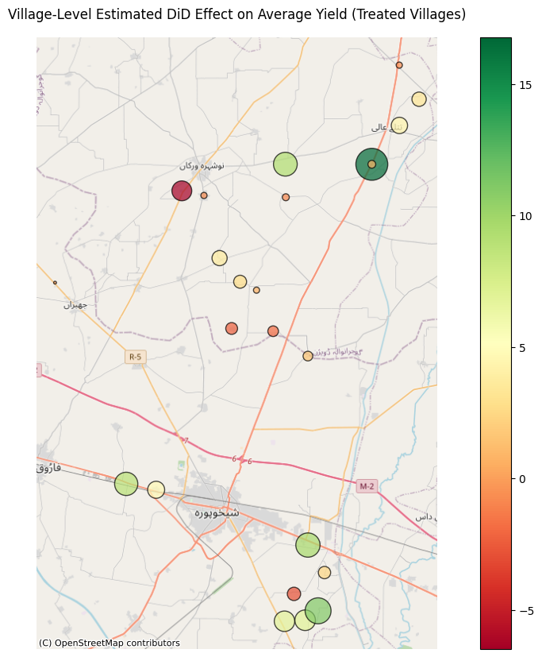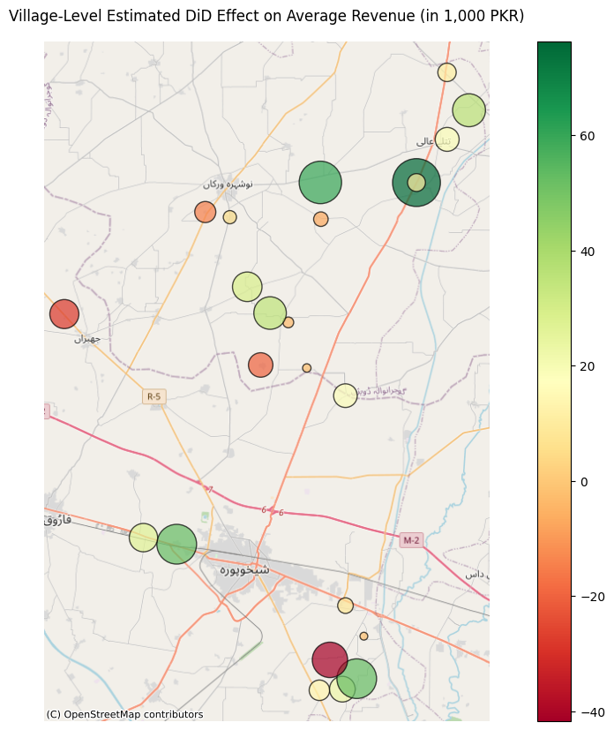
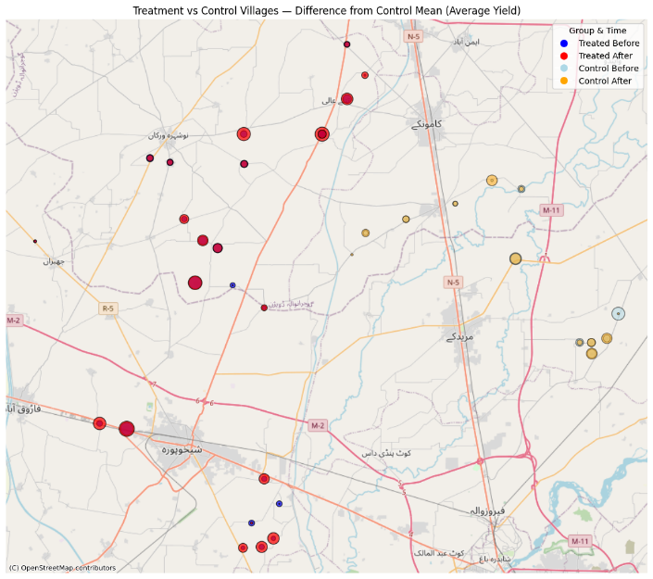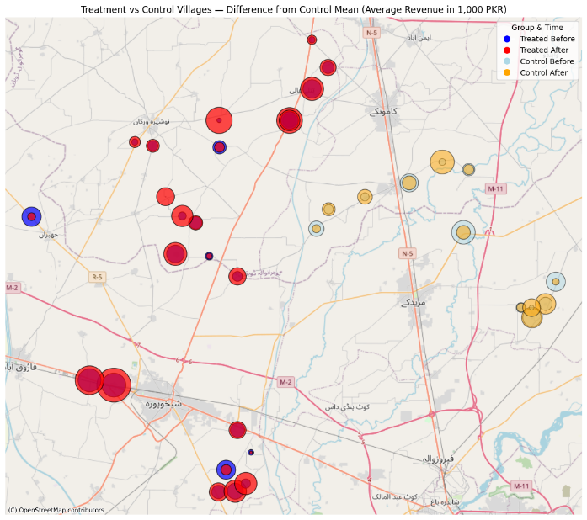
Figure 4: Comparison of Differences in Yield and Revenue Estimates by Village
  - Spillover Effects
An important concern in field-based information interventions is the possibility that knowledge provided to treated farmers may diffuse to nearby control areas through informal social interactions, potentially biasing the estimated treatment effect downward. To assess this potential spillover, we constructed a bordering dummy variable, equal to 1 for villages geographically adjacent to the treatment–control boundary and zero otherwise.
Table 4 presents the results of this robustness test, which uses the exact DiD specification and control variables as in the primary analysis. The findings indicate that the intervention’s effect on rice yield remains large and statistically significant for farmers in non-bordering treatment villages, with an estimated gain of 4.27 maunds per acre. In contrast, the estimated effect in bordering villages is negligible at 0.07 maunds per acre and statistically insignificant, suggesting that proximity to treated areas may have exposed control farmers to unintended information flows. A similar pattern emerges for average revenue: non-bordering treatment villages experienced a significant gain of PKR 12,626 per acre. In contrast, bordering villages saw a decline of PKR 18,676, likely reflecting partial knowledge transfer that reduced the yield gap between groups but did not fully replicate the impact of the structured training. Taken together, these results provide credible evidence of spillover effects at the treatment–control margin. They also imply that our main estimates may be conservative, as informal sharing of agronomic information likely improved yields for some farmers in bordering control villages. This is consistent with the practical reality that farmers may exchange knowledge across village boundaries, especially in closely settled rural settings.
Table 4. Comparison of Effect between Bordering Villages and Non-Bordering Villages
 | Average Yield |  |  | Average Revenue
 | (Bordering Village = No) | (Bordering Village = Yes) |  | (Bordering Village = No) | (Bordering Village = Yes)
Diff-in-Diff (Treatment*Post) | 4.27*** | 0.07 |  | 12,626.30** | -18,676.41
 | (1.18) | (2.43) |  | (5,317.41) | (17,588.12)
Treatment | -3.25 | -0.02 |  | 12,594.09 | 24,376.79
 | (2.86) | (2.74) |  | (12,877.72) | (19,842.12)
Post | -10.00*** | -9.56*** |  | -4,857.26 | 9,501.39
 | (0.84) | (1.67) |  | (3,794.29) | (12,075.14)
All Controls | YES | YES |  | YES | YES
Village Fixed Effects | YES | YES |  | YES | YES
R-squared | 0.50 | 0.71 |  | 0.42 | 0.38
Observation | 526 | 77 |  | 526 | 77
Notes: Villages located along the border are designated as a value of one, whereas all other villages are assigned a value of zero. Standard errors are within parentheses. Statistical significance at the 1%, 5%, 10% is denoted by ***, **, *. Respectively.

Our findings align with prior work by Nakano et al. (2018) and Takahashi et al. (2019) that emphasize the role of information in improving rice productivity. However, while these studies highlight peer-to-peer learning mechanisms such as farmer-to-farmer knowledge exchange or collaborative learning, our results demonstrate that even centrally delivered, exogenous information can generate significant economic gains when effectively implemented. These findings are plausible and aligned with broader evidence on the effectiveness of information-based interventions in rural markets. Hasanain et al. (2023) demonstrate that providing farmers with ratings of veterinarians in rural Punjab resulted in higher insemination success and increased reliance on government service providers. Although their focus is on livestock, the underlying mechanism information prompting greater engagement with the public extension system is closely related to ours. In our setting, farmers received agronomic information through extension agents prior to the rice season, and we similarly observe significant improvements in outcomes. The parallel findings across sectors strengthen the case that well-delivered, exogenous information can shift behavior and improve productivity in rural agricultural systems.
- Discussion
Agricultural extension services remain central to addressing persistent productivity gaps in developing countries by bridging the divide between research and practice. Well-functioning extension systems connect scientific advances with on-the-ground realities, equipping farmers with context-specific knowledge that can raise yields, improve resilience, and strengthen rural livelihoods (Ogundari, 2014; Danso-Abbeam et al., 2018; Argaw et al., 2023; Raji et al., 2024). For staple crops like rice, which underpin food security and export earnings in Pakistan , effective delivery of timely agronomic information is particularly critical (Anang et al., 2020; Nakano et al., 2018; Takahashi et al., 2019).
Our findings provide evidence of the varied role of extension services. Specifically, we demonstrate that the mere presence of an extension system is insufficient; productivity gains materialize only when targeted, timely training is delivered in ways that align with farmers’ local agro-ecological contexts and knowledge needs (Ayalew et al., 2022). The positive, significant yield and revenue effects we document reinforce previous evidence that information is itself a critical input in the agricultural production function (Feder & Savastano, 2006; Conley & Udry, 2010).
However, our analysis also reveals that the current public extension infrastructure in Punjab, although extensive on paper, suffers from capacity and implementation gaps that limit its effectiveness—a challenge widely noted across developing-country settings (Adio et al., 2016). Without structured and context-specific delivery, smallholders remain reliant on informal knowledge networks, local dealers, or private services that often fail to provide accurate or unbiased recommendations (Labarthe & Laurent, 2013; Bruce & Costa, 2019). Our spillover analysis further highlights how information can diffuse through social ties, consistent with the literature on peer learning and “learning through noticing” (Foster & Rosenzweig, 1995; Munshi, 2004; BenYishay & Mobarak, 2018). While such diffusion may modestly benefit neighboring farmers, our results confirm that informal spillovers alone do not substitute for well-designed, direct training interventions.
These insights carry clear policy implications. First, expanding the reach of extension services through relevant and updated content, effective delivery, and the timeliness of information would close the yield gap. Localized, phase-based training, as demonstrated in this study, can yield measurable productivity gains at a relatively low cost. Second, in the context of a typical developing country like Pakistan, extension agents must be equipped and incentivized to reach smallholders, rather than focusing disproportionately on large-scale farms, which is essential for equity and efficiency (Ferroni & Zhou, 2012; Ali & Rahut, 2013). This requires performance-based monitoring, adequate staffing, and investments in training extension personnel themselves (Buehren et al., 2017). Third, our results underscore the value of leveraging existing public extension infrastructure for scalable interventions, but they also point to the risk of dilution if delivery is not carefully targeted. As seen in other contexts, hybrid approaches that combine public delivery with community-based facilitators, local demonstration plots, or ICT-enabled advisory tools can expand reach while maintaining relevance and accountability (Pan et al., 2018; Ragasa, 2020; Baul et al., 2024; Kondylis et al., 2017; Lasdun et al., 2025). Finally, the clear evidence of peer-spillovers suggests that policymakers should view farmers’ social networks as a complement, not a substitute for formal training (Fernando, 2021; Kondylis et al., 2017; Bandiera & Rasul, 2006). Well-designed programs can harness this channel deliberately, for example, by identifying local opinion leaders, incentivizing lead farmers to disseminate good practices, or using peer demonstration models to amplify impact (BenYishay & Mobarak, 2018; Kondylis et al., 2017).
Taken together, this study contributes by revitalizing extension services through targeted, context-specific information delivery, which can yield meaningful gains in productivity and rural incomes, even in resource-constrained settings. Scaling such interventions will require not only institutional commitment and adequate funding but also careful attention to how knowledge circulates within and across communities. For Punjab’s rice growers, strengthening the capacity and accountability of the extension network offers a cost-effective path to closing persistent yield gaps and advancing the twin goals of food security and export competitiveness.
- Conclusion
This study leverages a natural experiment to provide new causal evidence on the role of targeted agronomic information in improving smallholder rice productivity in selected districts of Central Punjab, Pakistan. The study uses a pragmatic sampling approach by partnering with the provincial extension system and exploiting existing variation in staff availability across tehsils thus, we isolate the effect of delivering timely, locally relevant knowledge to farmers who otherwise face persistent information frictions. Within treatment tehsils, villages were randomly selected, and farmers received structured, phase-based training prior to and during the rice cultivation season, covering both farm practices and integrated pest management.
Our difference-in-differences estimates show that this targeted information intervention generated substantial productivity gains. Treated farmers achieved an average yield increase of 4.64 maunds per acre, translating into a significant rise in revenue of approximately PKR 16,999 per acre. These results hold robustly across specifications controlling for farm size, farming experience, input use, and household demographics. Additional spillover analysis further indicates that some information did diffuse informally to nearby control villages. However, the core effect remains strong when non-bordering villages are isolated, underscoring that structured, direct knowledge transfer is crucial for driving yield gains at scale.
These findings suggest that the mere presence of extension staff is not sufficient to bridge productivity gaps among farmers. Without timely, practical, and context-specific training, smallholders continue to rely on informal channels or private advisors that often fail to deliver high-quality recommendations. This study demonstrates that revitalizing existing extension infrastructure through targeted content and improved delivery mechanisms can unlock meaningful gains in productivity and rural incomes, even in resource-constrained settings.
For policymakers, the implications are obvious. Strengthening public extension systems requires not just more exhaustive coverage but deeper engagement with smallholders’ specific needs. Investments in training and equipping extension agents, adopting phase-based curricula, and leveraging farmer networks can help amplify the reach of updated agronomic information, ensuring that it translates into tangible on-farm outcomes. By aligning institutional capacity with farmer-centered delivery, governments can transform extension services into a reliable vehicle for sustainable agricultural growth, export competitiveness, and rural welfare.
Future research could build on these insights by exploring complementary innovations, such as digital advisory tools, lead farmer models, or incentive-based delivery, to further enhance adoption and knowledge retention. In Pakistan and other similar contexts, such evidence can guide the design of scalable, cost-effective policies to close persistent yield gaps and strengthen food security in an era of mounting production challenges.
References
Adetimehin, O. D., Okunlola, J. O., & Owolabi, K. E. (2018). Utilization of agricultural information and knowledge for improved production by rice farmers in Ondo State, Nigeria. Journal of Rural Social Sciences, 33(1), 76–100.
Adio, E. O., Abu, Y., YUsuf, S. K., & Nansoh, S. (2016). Use of agricultural information sources and services by farmers for improve productivity in Kwara State. Library Philosophy and Practice, 1456, 1-16.
Ali, A., & Rahut, D. B. (2013). Impact of agricultural extension services on technology adoption and crops yield: Empirical evidence from Pakistan. Asian Journal of Agriculture and Rural Development, 3(393-2016-23855), 801–812.
Anang, B. T., Bäckman, S., & Sipiläinen, T. (2020). Adoption and income effects of agricultural extension in northern Ghana. Scientific African, 7, e00219.
Anderson, J. R., & Feder, G. (2004). Agricultural extension: Good intentions and hard realities. The World Bank Research Observer, 19(1), 41–60.
Argaw, B., Yehuala, K., & Aschalew, A. (2023). Review on the role of agricultural extension Service on increasing farm productivity in Ethiopia. International Journal of Finance Research, 4(2), 77–89.
Ayalew, H., Chamberlin, J., & Newman, C. (2022). Site-specific agronomic information and technology adoption: A field experiment from Ethiopia. Journal of Development Economics, 156, 102788.
Bandiera, O., & Rasul, I. (2006). Social Networks and Technology Adoption in Northern Mozambique. The economic journal, 116(514), 869-902.
Barham, B. L., Chavas, J. P., Fitz, D., & Schechter, L. (2018). Receptiveness to advice, cognitive ability, and technology adoption. Journal of Economic Behavior & Organization, 149, 239–268.
Baul, T., Karlan, D., Toyama, K., & Vasilaky, K. (2024). Improving smallholder agriculture via video-based group extension. Journal of Development Economics, 169, 103267.
BenYishay, A., & Mobarak, A. M. (2019). Social learning and incentives for experimentation and communication. The Review of Economic Studies, 86(3), 976-1009.
Blum, F. (2020). The value of discretion: Price-caps and public service delivery. Journal of Development Economics, 146, 102521.
Bruce, K., & Costa, H. (2019). Enabling environment for PPPs in agricultural extension projects: Policy imperatives for impact. Journal of Rural Studies, 70, 87–95.
Buehren, N., Goldstein, M., Molina, E., & Vaillant, J. (2017). The impact of strengthening agricultural extension services: evidence from Ethiopia. World Bank Policy Research Working Paper, (8169).
Cole, S., Harigaya, T., Killeen, G., & Krishna, A. (2025). Using satellites and phones to evaluate and promote agricultural technology adoption: Evidence from smallholder farms in India. Journal of Development Economics, 176, 103463.
Conley, T. G., & Udry, C. R. (2010). Learning about a new technology: Pineapple in Ghana. American Economic Review, 100(1), 35–69.
CRS (2022). Historical Crops Data. Crop Reporting Service, Government of the Punjab, Lahore. https://crs-agripunjab.punjab.gov.pk/system/files/Rice%201990-21.pdf
Danso-Abbeam, G., Ehiakpor, D. S., & Aidoo, R. (2018). Agricultural extension and its effects on farm productivity and income: insight from Northern Ghana. Agriculture & Food Security, 7(1), 1-10.
Deutschmann, J. W., Duru, M., Siegal, K., & Tjernström, E. (2025). Relaxing multiple agricultural productivity constraints at scale. Journal of Development Economics, 174, 103409.
Devkota, R., Hambly Odame, H., Fitzsimons, J., Pudasaini, R., & Raizada, M. N. (2020). Evaluating the effectiveness of picture-based agricultural extension lessons developed using participatory testing and editing with smallholder women farmers in Nepal. Sustainability, 12(22), 9699.
Dinar, A., Karagiannis, G., & Tzouvelekas, V. (2007). Evaluating the impact of agricultural extension on farms' performance in Crete: a non-natural stochastic frontier approach. Agricultural Economics, 36(2), 135-146.
Feder, G., & Savastano, S. (2006). The role of opinion leaders in the diffusion of new knowledge: The case of integrated pest management. World Development, 34(7), 1287–1300.
Fernando, A. N. (2021). Seeking the treated: The impact of mobile extension on farmer information exchange in India. Journal of Development Economics, 153, 102713.
Ferroni, M., & Zhou, Y. (2012). Achievements and challenges in agricultural extension in India. Global Journal of Emerging Market Economies, 4(3), 319-346.
Foster, A. D., & Rosenzweig, M. R. (1995). Learning by doing and learning from others: Human capital and technical change in agriculture. Journal of Political Economy, 103(6), 1176-1209.
Gebresilasse, M. (2023). Rural roads, agricultural extension, and productivity. Journal of Development Economics, 162, 103048.
Government of Pakistan (GOP), Ministry of Finance. (2022). Pakistan Economic Survey 2021–22: Agriculture. https://www.finance.gov.pk/survey/chapter_22/PES02-AGRICULTURE.pdf
Hanna, R., Mullainathan, S., & Schwartzstein, J. (2014). Learning through noticing: Theory and evidence from a field experiment. The Quarterly Journal of Economics, 129(3), 1311–1353.
Hasanain, S. A., Khan, M. Y., & Rezaee, A. (2023). No bulls: Experimental evidence on the impact of veterinarian ratings in Pakistan. Journal of Development Economics, 161, 102999.
Jones, M., & Kondylis, F. (2018). Does feedback matter? Evidence from agricultural services. Journal of Development Economics, 131, 28-41.
Kidd, A. D., Lamers, J. P. A., Ficarelli, P. P., & Hoffmann, V. (2000). Privatising agricultural extension: caveat emptor. Journal of Rural Studies, 16(1), 95–102.
Kondylis, F., Mueller, V., & Zhu, J. (2017). Seeing is believing? Evidence from an extension network experiment. Journal of Development Economics, 125, 1-20.
Labarthe, P., & Laurent, C. (2013). Privatization of agricultural extension services in the EU: Towards a lack of adequate knowledge for small-scale farms?. Food policy, 38, 240–252.
Lasdun, V., Harou, A., Magomba, C., & Guereña, D. (2025). Peer learning and technology adoption in a digital farmer-to-farmer network. Journal of Development Economics, 103496.
Lobell, D. B., Cassman, K. G., & Field, C. B. (2009). Crop yield gaps: their importance, magnitudes, and causes. Annual review of environment and resources, 34, 179–204.
Munshi, K. (2004). Social learning in a heterogeneous population: technology diffusion in the Indian Green Revolution. Journal of Development Economics, 73(1), 185–213.
Nakano, Y., Tsusaka, T. W., Aida, T., & Pede, V. O. (2018). Is farmer-to-farmer extension effective? The impact of training on technology adoption and rice farming productivity in Tanzania. World Development, 105, 336-351.
Ogundari, K. (2014). The paradigm of agricultural efficiency and its implication on food security in Africa: what does meta-analysis reveal? World Development, 64, 690-702.
Orlando, F., Alali, S., Vaglia, V., Pagliarino, E., Bacenetti, J., & Bocchi, S. (2020). Participatory approach for developing knowledge on organic rice farming: Management strategies and productive performance. Agricultural systems, 178, 102739.
Pan, Y., Smith, S. C., & Sulaiman, M. (2018). Agricultural extension and technology adoption for food security: Evidence from Uganda. American Journal of Agricultural Economics, 100(4), 1012-1031.
Ragasa, C. (2020). Effectiveness of the lead farmer approach in agricultural extension service provision: Nationally representative panel data analysis in Malawi. Land Use Policy, 99, 104966.
Raji, E., Ijomah, T. I., & Eyieyien, O. G. (2024). Improving agricultural practices and productivity through extension services and innovative training programs. International Journal of Applied Research in Social Sciences, 6(7), 1297-1309.
Serote, B., Mokgehle, S., Du Plooy, C., Mpandeli, S., Nhamo, L., & Senyolo, G. (2021). Factors influencing the adoption of climate-smart irrigation technologies for sustainable crop productivity by smallholder farmers in arid areas of South Africa. Agriculture, 11(12), 1222.
Takahashi, K., Mano, Y., & Otsuka, K. (2019). Learning from experts and peer farmers about rice production: Experimental evidence from Côte d’Ivoire. World Development, 122, 157-169.
Van Driessche, P. A. (2024). Agricultural producer Markets in the Maldives: how poor market connectivity between farmers and the markets can be enhanced. International Journal of Rural Management, 20(1), 24-44.

Corresponding Author
We thank the Department for Agricultural Extension Services in Punjab for cooperating in conducting this research. We also thank local community leaders who offered their cooperation in gathering the farmers on designated locations for dissemination of updated information. We are also grateful to the Higher Education Commission (HEC) and the Nation University of Sciences & Technology (NUST) for financial support in data collection and completion of this project. We are also grateful to the Graduate Evaluation Committee (GEC) members of the School of Social Sciences & Humanities (S3H) at NUST for their valuable comments. We also thank the anonymous review of International Conference on Business, Management and Social Science for their valuable feedback and comments for improvements.
The bordering villages in our sample include Usmanpur, Shamsa, Shamsa Dhadhy, Tatlay Hakim Haider, Kingarali Kalan, and Drajke.

